Fintug/VNUG crusaders 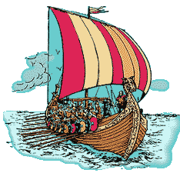

To say that we where on a crusade is maybe to much, but we hade a Fintug and VNUG joint event at a cruise between Stockholm and Helsinki. Thanks a lot to all participants that made this event to a new success to add to our former ones. A special mark of gratitude is to our participants Comforte, Golden gate, Xypro, Crystal Point and HP. As always it is very interesting to hear other user presentations and at this meeting we had Swedbank, Rahaxi and CEKAB that shared their experiences.

As you maybe already noticed you will find all presentations from the meeting at www.vnug.biz under News.

You will also find a summary of our evaluation forms at the same place. It was very positive feedback from the meeting and also some thoughts for the future. We have already started to plan for the next event and we will use all incoming thoughts to make the next meeting to a new grand success. When and where the 2008 VNUG meeting will be is also depending if the ITUG Europe will be held in Stockholm or not. We are still waiting on the ITUG board.

Once again, thanks a lot to all participants and partners making 2007 year event to such happening.

Regards,
VNUG board
